**User Guide**

**Log In**

The first screen all users will see is the login screen.

Employees can register or login to their accounts using this screen.

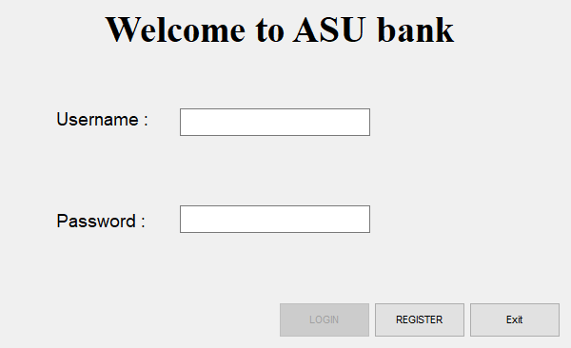

**Registration**

The Registration form allows for both employee and customer registration.

The first tab takes personal information about the person registering in the bank.

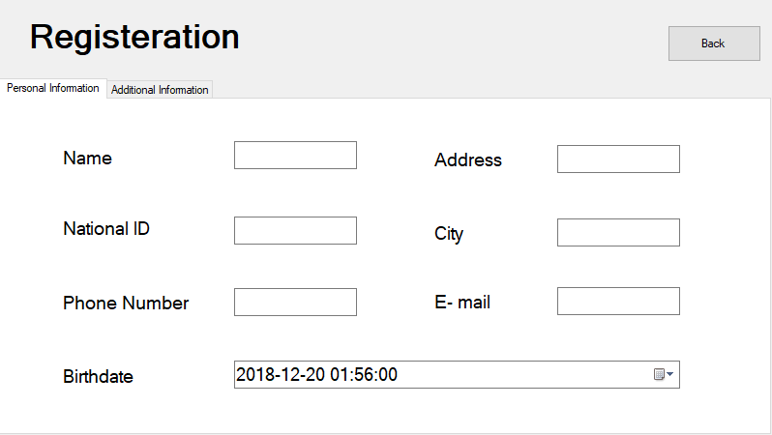

The second tab gives the option either to register as an employee or a customer.

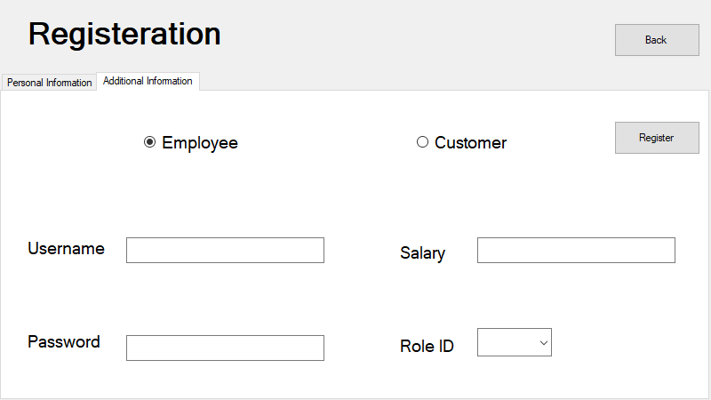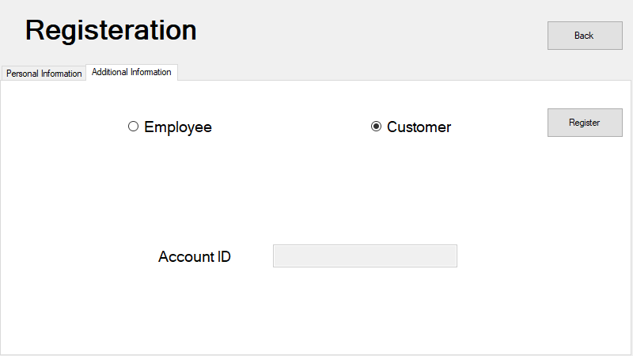

In employee panel:

Username will be the employee’s username to log into system.

Password will be the employee’s password to log into system.

Salary is the employee’s salary.

Role ID is his role in the bank (Manager, Teller, Bookkeeper, financial manager).

In customer panel:

Account ID text field will show the new customer’s account ID (his account number) after the new creation.

**Services**

After Login, all employees will go to the service page. However, according to each employee’s role, the corresponding services will be available.

* Financial managers: can create sub account for customers and issue them card.
* Teller: allow customers to withdraw and deposit funds from and to their accounts.
* Bookkeeper: manages the transfer of funds between accounts.
* Manager: allow employees to adjust their personal information as well as their account username and password.

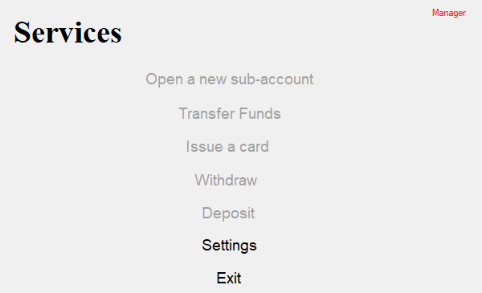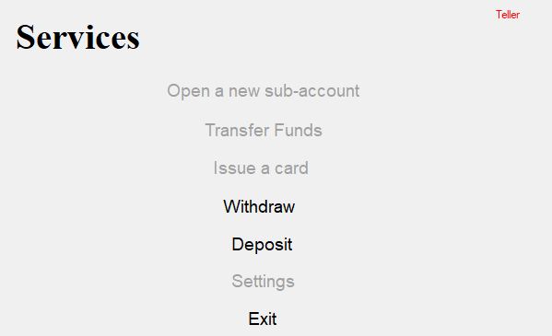

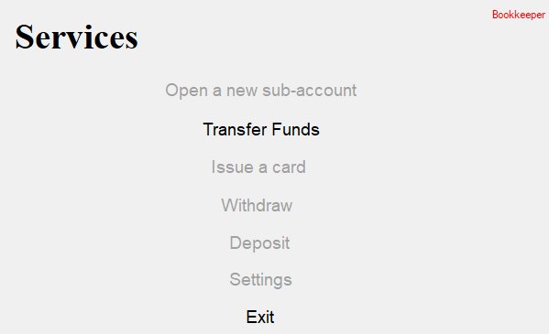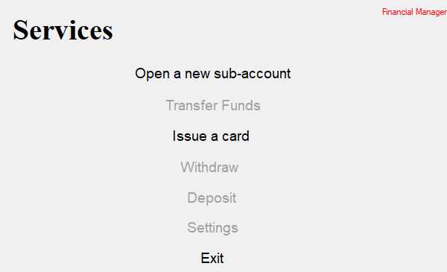

**New Subaccount Form**

In this form the financial manager can create a new sub account for a customer.

The customer has to tell the financial manager his account ID and what type of account he wants (checking, saving, dividend and current account) and which currency he wants his account in.

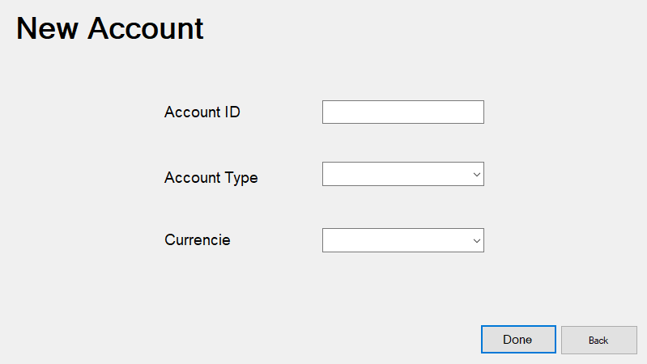

**Issue Card Form**

When a customer needs to create a new card, he has to go to the financial manager who will ask him for his Account ID and which issuer he want to create the card with (visa, Mastercard, American Express, chase, discover, Citibank, capital one) , ,the card duration ( 3 , 5 or 7 years),Daily limit for card and finally the card type(debit or credit).

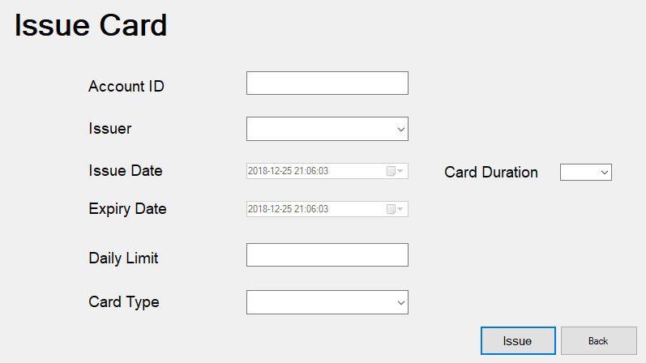

**Withdraw Form**

The teller is responsible for depositing and withdrawing money from customers' accounts.

In this Form, the customer tells the teller his account number and which account he wants to withdraw form and the amount to withdraw.

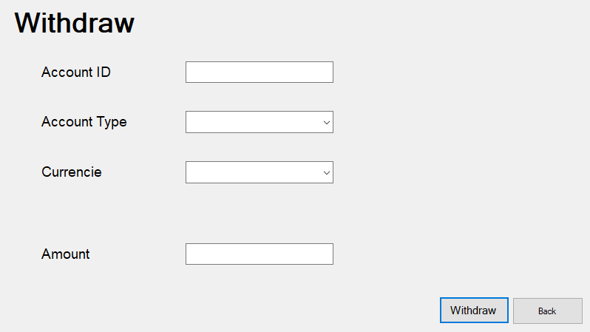

**Deposit Form**

In this Form, the customer tells the teller his account number and which account he wants to deposit in and the amount to deposit.

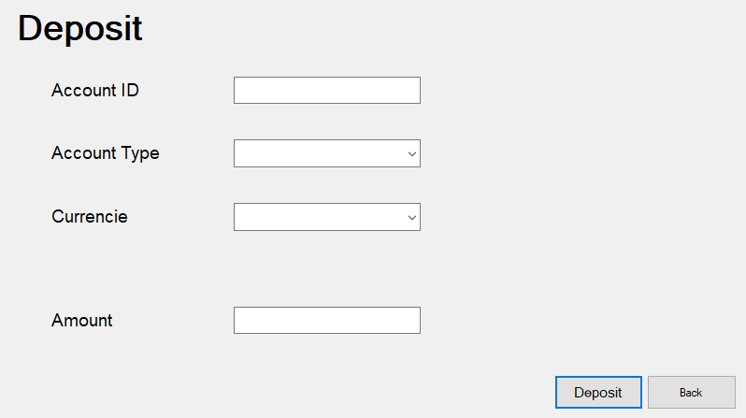

**Transfer Fund Form**

In this form, the bookkeeper can transfer fund from an account to another

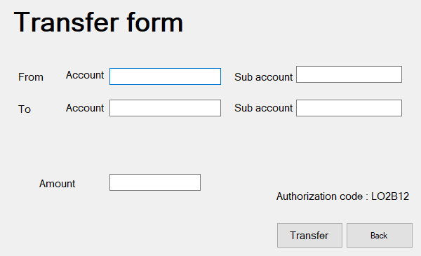

**Settings Form**

The manager is the only individual with access to the settings forms, he can change personnel information as well as username and password of employee account.

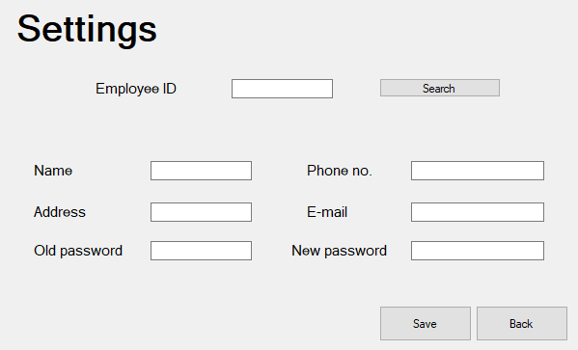

**View Transaction**

In this form, the employee can view all transactions in a specific branch and filter them according to the amount.

He can also filter sort them by customer name or by the transaction amount and sort them accordingly.

